Planning and Progress Report



**Group Number:** C1.037  
**Repository:** <https://github.com/DP2-C1-037/Acme-ANS-D01>

**Workgroup Members:**

Student 1: Ignacio Gutiérrez Serrera - [igngutser@alum.us.es](mailto:igngutser@alum.us.es)

Student 2: Adrián Chabrera Rubio - [adrcharub@alum.us.es](mailto:adrcharub@alum.us.es)

Student 3: Miguel Álvarez Raya - [migalvray@alum.us.es](mailto:migalvray@alum.us.es)

Student 4: Salma El Hakimy - [salel@alum.us.es](mailto:salel@alum.us.es)

Student 5: Alejandro González Macías- [alegonmac@alum.us.es](mailto:alegonmac@alum.us.es)

**Date:** 20/02/2025

Table of Contents

1 Executive Summary 3

2 Revision Table 4

3 Introduction 4

4 Contents 4

4.1 Content 1 5

4.2 Content 2 5

4.3 Content 3 5

5 Conclusions 5

6 Bibliography 5

# Executive Summary

This report provides a comprehensive overview of the task planning and progress for the project deliverable, detailing both the planning and execution phases. The planning chapter includes a breakdown of tasks performed, with a clear description of each task, the assigned roles, and the time estimates versus actual time spent. It also highlights the estimated budget, detailing personnel costs and amortisation using a linear depreciation method. The progress chapter follows, outlining the performance of team members, the conflicts that arose, and how they were resolved, along with a comparison between the estimated and actual costs, offering insights into the financial performance of the project.

# Revision Table

|  |  |  |
| --- | --- | --- |
| **Revision Number** | **Date** | **Description** |
| 1.0 | 20/02/2025 | Final version |

# Introduction

This report is structured into two main chapters: planning and progress. The planning chapter focuses on the tasks performed to fulfil the requirements of the deliverable, the time and resources allocated, and the estimated costs associated with the completion of the project. Additionally, it provides a visual representation of the task progression, showing screenshots at various stages of the work. The progress chapter, on the other hand, addresses the actual performance during the execution phase, including team member contributions, any conflicts encountered, and a comparison of the initial budget estimates with the final costs. By reviewing these areas, the report aims to provide an understanding of how the project evolved, how tasks were managed, and the final outcomes in terms of time and cost.

# Contents

[Main body of the report. Include relevant sections and details based on the subject matter.]

## Planning

The following table lists the tasks performed to fulfill the requirements of this deliverable:

|  |  |  |  |  |  |
| --- | --- | --- | --- | --- | --- |
| **Task Title** | **Description** | **Assignee** | **Role(s)** | **Estimated Completion Time** | **Actual Time (h)** |
| Getting the environment ready and familiarizing with projects | Setting up the development environment and understanding project structure | Ignacio | DeveloperTester | 10h | 11.5h |
| Modify anonymous menu | Implementing the necessary changes in the menu | Ignacio | DeveloperTester | 30min | 1h |
| Add planning dashboard link | Adding a direct link to the planning dashboard | Ignacio | DeveloperTester | 6min | 3min |
| Planning and progress report | Documenting the planning and progress of the tasks | Ignacio | DeveloperTester | 1h | 2h |
| Analysis report | Conducting the analysis of the deliverable | Ignacio | DeveloperTester | 1h | 1h |

## Screenshots of tasks

**Todo**

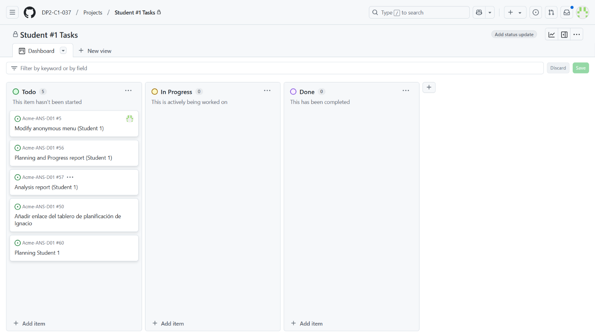

**In progress**  
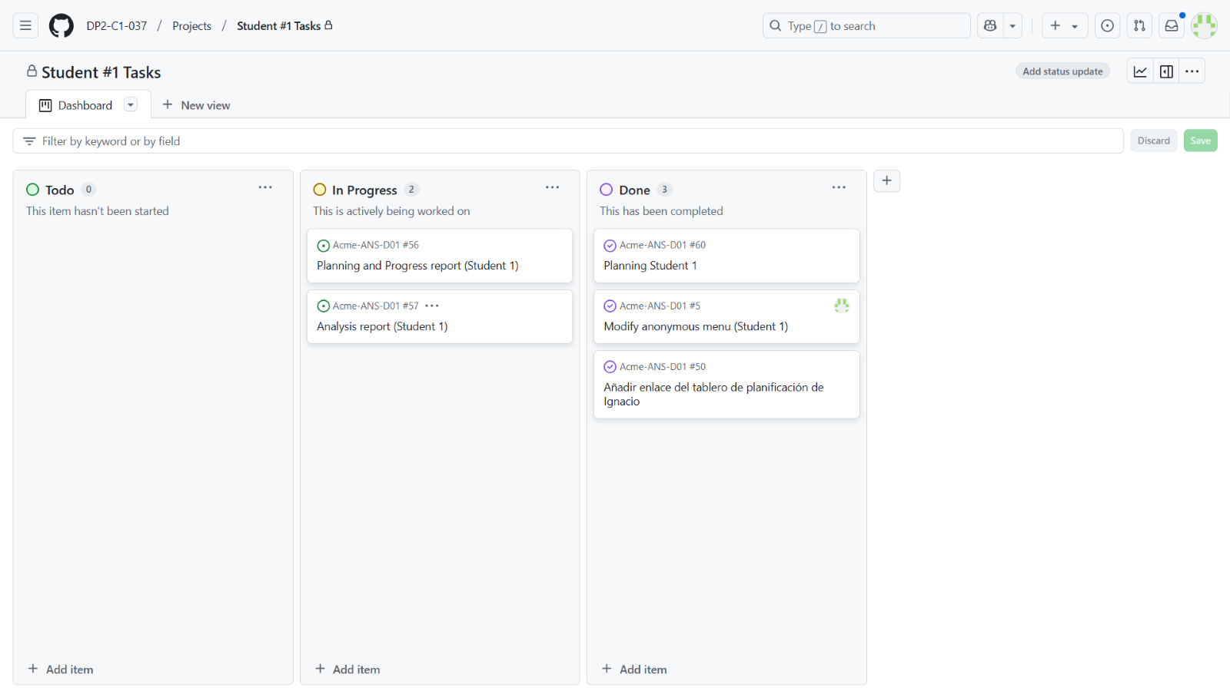

**Done**

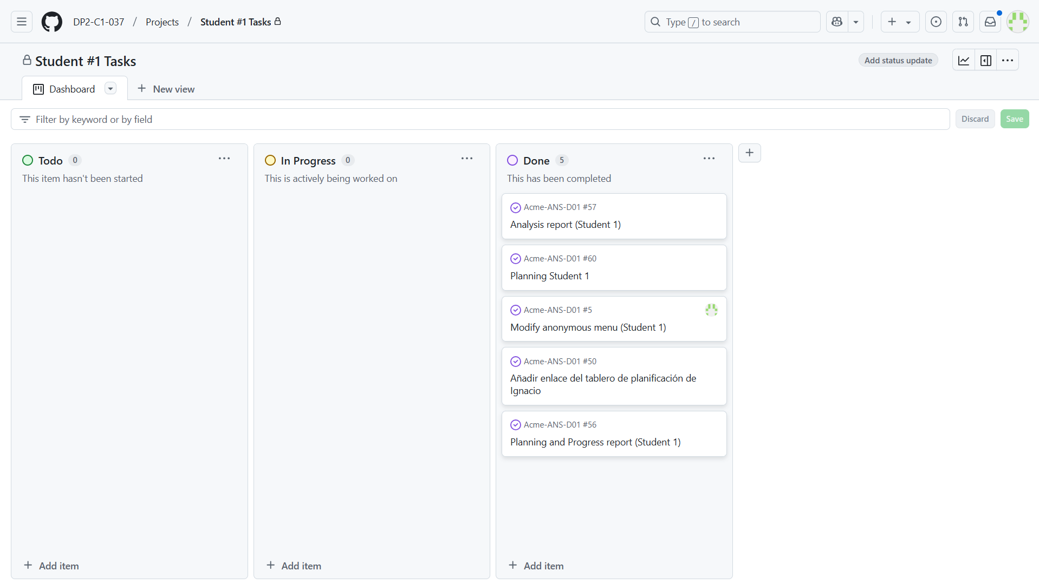

## Budget comparison

The total estimated cost required for these tasks is calculated as follows:

|  |  |  |  |  |  |  |
| --- | --- | --- | --- | --- | --- | --- |
| Role | Estimated Hours | Real hours | Cost per Hour (€) | Estimated Cost (€) | Real cost | Amortisation Cost |
| Developer, tester | 12.6 | 15.55 | 20 | 252 | 311 | 19.67 |

Amortisation cost is computed using a linear depreciation method over three years.

annual_amortisation_cost = (real_cost - estimated_cost) / amortisation_period_years -> (real_cost - estimated_cost) / 3

## Progress chapter

**Progress Records**

* **Team Member**: Ignacio – Student 1  
  **Performance Indicator**: I have completed both my mandatory and supplementary II tasks.  
  **Evaluation**: Great  
  **Reward/Admonishment**: recognition from the group.

**Conflicts arisen and how I have addressed them**

**- Difficulty with Identifying the Correct Section for Personal Information**

* **Requirement**: The assignment required personal information to be entered in a specific section of the code, but I was unsure where exactly to place it.
* **Analysis**: I initially couldn’t find the section where this information should be entered. After some searching and checking the "S04 - Getting Started" module, I located the correct part of the code.
* **Resolution**: I adjusted my approach by carefully reviewing all instructions in the future to avoid confusion.

**- Issue with Uploading the URL to the Planning Dashboard**

* **Requirement**: I needed to upload the URL to my planning dashboard hosted on GitHub.
* **Analysis**: I initially thought it was only necessary to include the URL in the document. I later realized it had to be uploaded both in the document and on GitHub.
* **Resolution**: Once I understood the full requirements, I uploaded the URL in both locations to complete the task.

**- Challenges with Completing the Planning and Progress Report**

* **Requirement**: The task required a detailed report about my planning and progress, including time tracking and resource management.
* **Analysis**: Collecting and organizing all the necessary information was time-consuming and challenging, especially since I needed to track both planning and progress.
* **Resolution**: I spent extra time organizing and updating my report, ensuring it reflected my work accurately.

**- Struggles with Initial Project Setup**

* **Requirement**: I had to set up the development environment and ensure the project was running correctly before proceeding.
* **Analysis**: The setup process was difficult due to unclear instructions for importing the "Hello World" project and configuring dependencies.
* **Resolution**: I reached out to my lecturer for help and received support from my classmates to import the project and set everything up correctly.

**Cost Comparison:** remit to point 4.3 for budget comparison.

# Conclusions

This report outlines the planning and progress of the deliverable, providing valuable insights into the project’s execution. The planning phase ensured that the tasks were well-defined and that the necessary resources were allocated. Despite some challenges encountered during the execution phase, the team adapted well and completed the deliverable successfully. The comparison between the estimated and actual costs indicates a clear picture of the project's financial performance, highlighting areas for future improvement. The report concludes that while the initial plan was largely effective, flexibility and communication were crucial in addressing unforeseen issues, ultimately ensuring the project's success.

# Bibliography

Intentionally blank.